Bahria University,

Karachi Campus



COURSE: SEN-310 WEB ENGINEERING

TERM: SPRING 2022, CLASS: BSE- 6 (B)

Open Ended Lab Exam

Submitted By:

MUHAMMAD SOHAIL ABBAS 02-131192-012 65128

(Name) (Reg. No.)

Submitted To:

ENGR. Syed Ahmed Hassan Bukhari, ENGR. Ayesha Khan

Submitted On:

19/05/2022

Signed Remarks: Score: Pakistan

**Task 1:**

**Solution:**

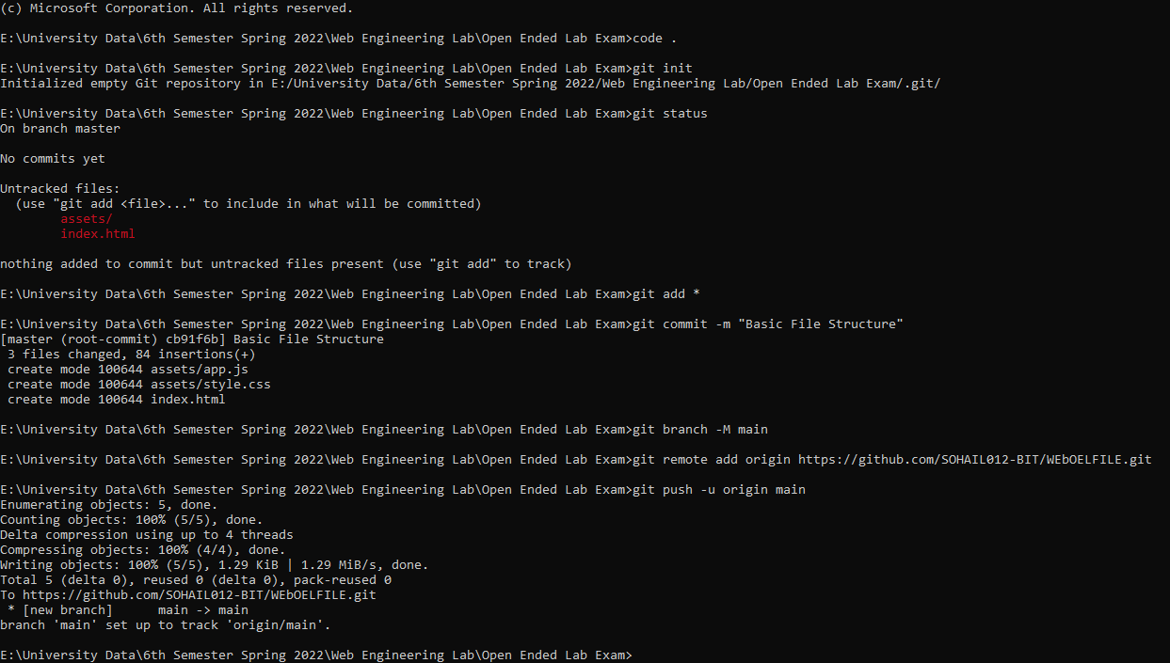**GitHub Upload:**